**Hello Team!** **Consider the below two tables**:

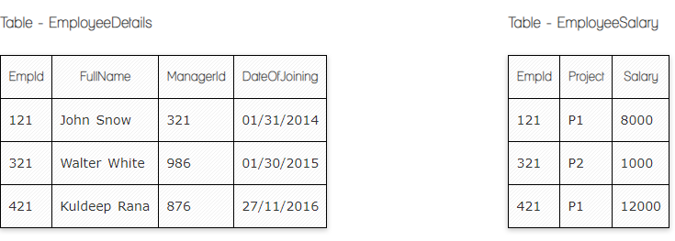

**Ques.1. Write a SQL query to fetch the count of employees working in project 'P1'.**

**Select Count(EmpId) of EmployeesWorkingIn-P1**

**From EmployeeSalary**

**Where Project=’P1’**

**From**

**Ques.2. Write a SQL query to fetch employee names having salary greater than or equal to 5000 and less than or equal 10000.**

**Your Answer:**

**Select EmployeeDetails.FullName**

**From EmployeeDetails**

**Inner Join EmployeeSalary**

**On EmployeeDetails.EmpId=EmployeeSalary.EmpId**

**Were salary between 5000and10000**

**Ques.3. Write a SQL query to fetch count of employees sorted by project's count in descending order.**

**Your Answer:**

**Select** count(EmplId) **as counter,Project**

**From EmployeeSalary**

**Group by project**

**Order by counter Desc**

**Ques.4. Write a query to fetch employee names and salary records. Return employee details even if the salary record is not present for the employee.**

**Your Answer:**

**Select EmployeeDetails.FullName,EmployeeSalary.Salary**

**from EmployeeDetails**

**Left Join EmployeeSalary**

**on EmployeeDetails.empId=EmployeeSalary.EmpId**

**Ques.5. Write a SQL query to create an empty table with ‘Test’ name.**

**Your Answer:**

**Create table Test(id int);--at least one column**

**Ques.6. Write a SQL query to delete an empty table with ‘Test’ name.**

**Your Answer:**

**Drop table Test**

**Ques.7. Write a SQL query to fetch all the Employees details from EmployeeDetails table who joined in Year 2016.**

**Your Answer:**

**Select * from EmployeeDetails**

**where DateOfJoining like '%2016%'**

**Ques.8. Write a SQL query to insert new record to the EmployeeDetails table with any data.**

**Your Answer:**

**Insert Into EmployeeDetails(FullName,DateOfjoining)**

**Values=(‘John Smith’, 18/10/2022)**

**Ques.9. Write a SQL query to update EmployeeSalery table with setting Salary to 2000 for Project P2.**

**Your Answer:**

**Update employeeSalary**

**Set Salary=2000**

**Were Project=’P2’**

**Ques.10. Write a SQL query to right join both tables and draw the results.**

**Your Answer:**

**Select EmployeeDetails. *, EmployeeSalary.\***

**From EmployeeDetails**

**Right Join EmployeeSalary**

**On EmployeeDetails. EmpId=EmployeeSalary. EmpId**

**Now take these two tables:**

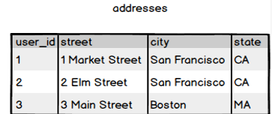

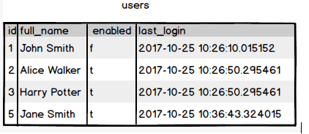

**Ques.11. Write a SQL query to fetch all users full_name from San Francisco.**

**Your Answer:**

**Select users.full_name, addresses.city**

**From users**

**Inner join addresses**

**On users.Id addresses. User_Id**

**Where city=’San Francisco’**

**Ques.12. Write a SQL query to fetch all users full_name, last_login who are enabled**

**Your Answer:**

**Select users. Full_name, users. Last_login**

**From users**

**Where enabled=’t’**

**Ques.13. Write a SQL query to fetch all users full_name who are not from Main street**

**Your Answer:**

**Select users.full_name--,addresses,street**

**From users**

**Inner join addresses**

**On users.Id=addresses,user_Id**

**Where street not like %Main street%**

**Ques.14. Write a SQL query to fetch all users full_name who are from Main street or San Francisco**

**Your Answer:**

**Select users.full_name --,addresses.street,addresses.city**

**from users**

**inner join addresses**

**on users.id=addresses.user_id**

**where street like ('%Main Street%') or city = 'San Francisco'**

**Ques.15. Write a SQL query to fetch user full_name who is equal to user_id from Boston (find user_id value in sub_query)**

**Your Answer:**

**Select full_name from users**

**Where Id=(Select user_Id from addresses**

**where city=’Boston’)**